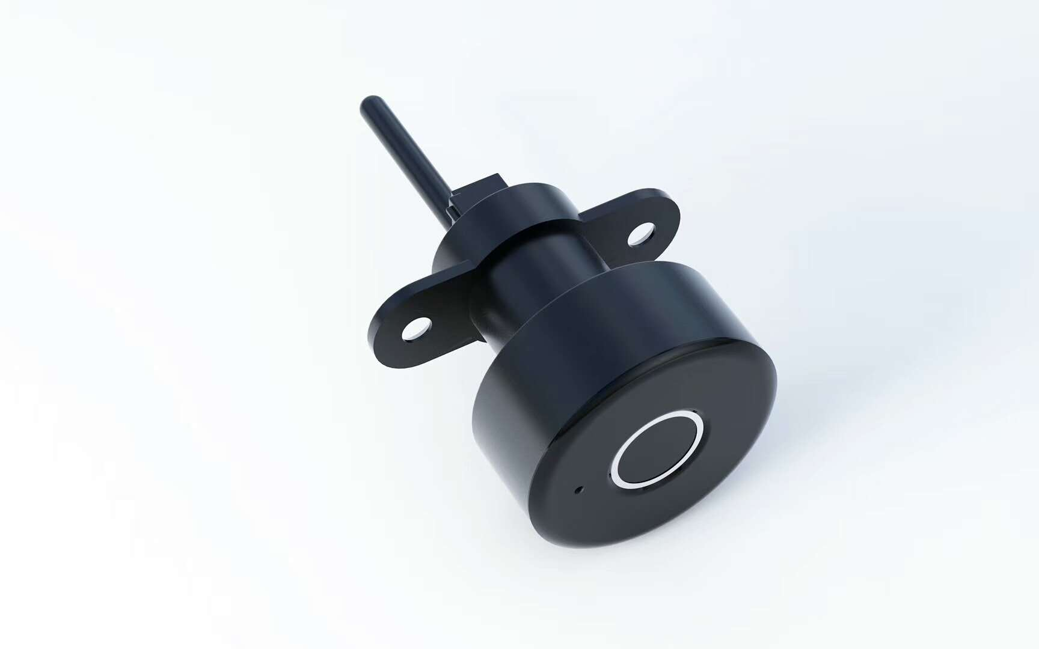

Fingerprint Cabinet Lock
User Manual

1 Product Details
  - Lock Size
  - Lock Package
1.2 Application
1.3 Function
2 Installation
2.1 Remove Mechanical Cabinet Lock
2.2 Right Side
2.3 Left Side
3 Open/Close
4 Operation Guide
4.1 Factory Mode
4.2 Admin Fingerprint Setting
4.3 Add User Fingerprint(s)
4.4 Delete All Fingerprint(s)
5 Features
1 Product Details
  - Lock Size
  - Lock Package
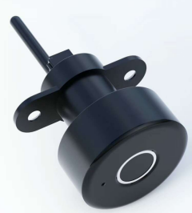 | 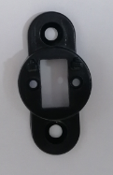 | 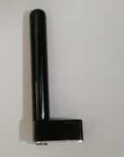 | 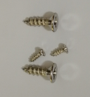
Lock Body | Baffle | Pick | Screws
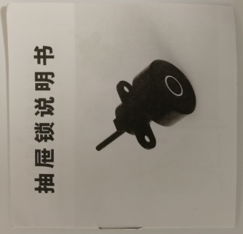 | 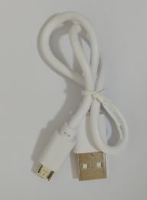 | 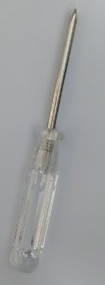
User Manual | Cable | Screwdriver

  - Application
Replace mechanical cabinet lock
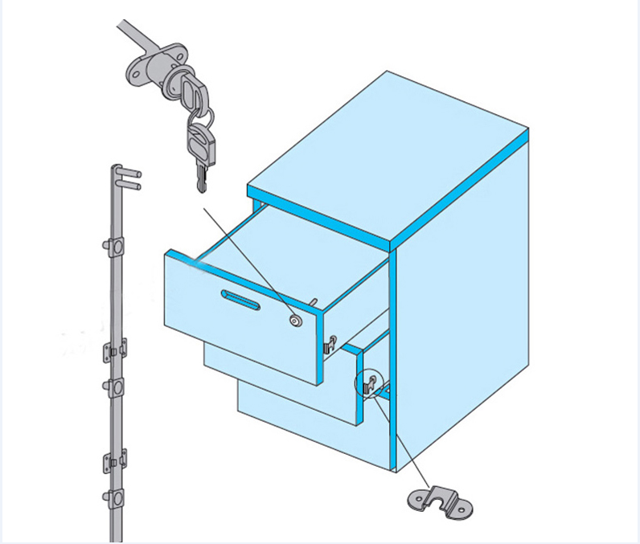
  - Function
Use the advance semiconductor international technology, 220mAh lithium battery inside, suitable to charge by mobile power bank.

2 Installation
2.1 Remove Mechanical Cabinet Lock
Remove the mechanical cabinet lock first, not necessary to dig hole or revise hole.

2.2 Right Side
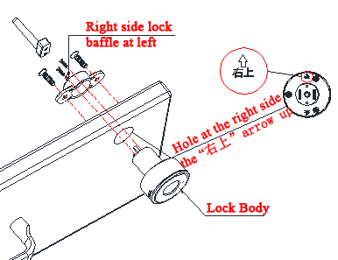
2.3 Left Side
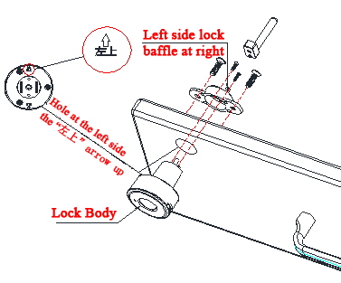

3 Open/Close
Press finger, motor moving, cabinet can be opened
Close cabinet, press finger, motor turning, cabinet locked
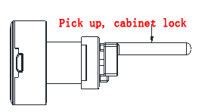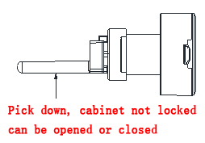
4 Operation Guide
4.1 Factory Mode
In this mode, there is no fingerprint record, any fingerprint can open/close lock.

4.2 Admin Fingerprint Setting

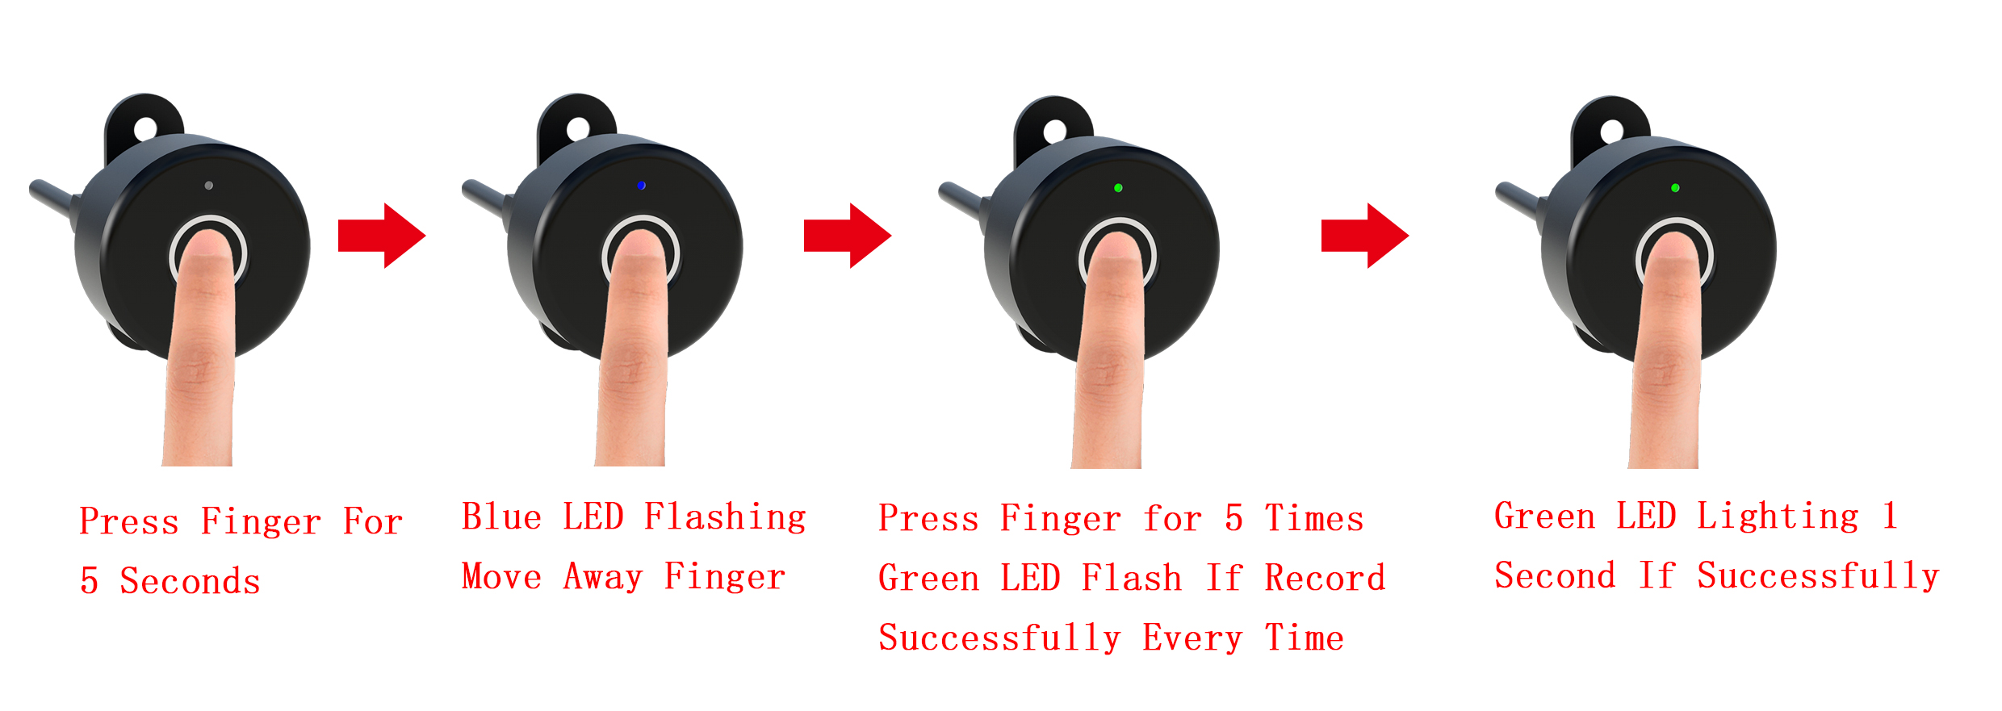
4.3 Add User Fingerprint(s)
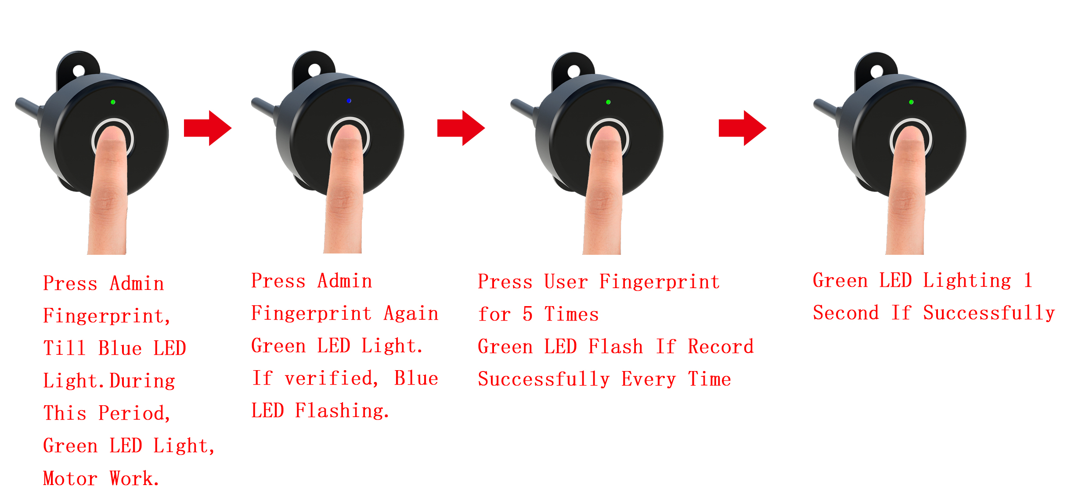
4.4 Delete All Fingerprint(s)
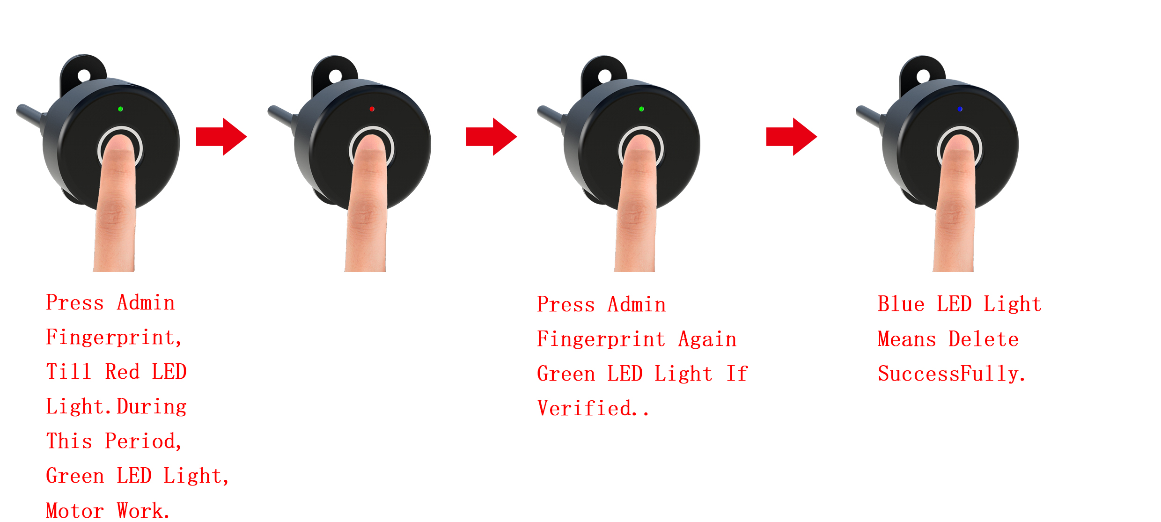
5 Features
1, Support 360° Any Direction Fingerprint Pressing;
2, Maximum 20pcs Fingerprints;
3, Resolution 508DPI;
4, ESD: ±12KV Air, ±8KV Contact;
5, FRR: 1%;
6, FAR: <0.002%;
7, Recognition Time: <300ms;
8, Working Environment: -20℃~70℃; Humidity: 40%RH-85%RH

