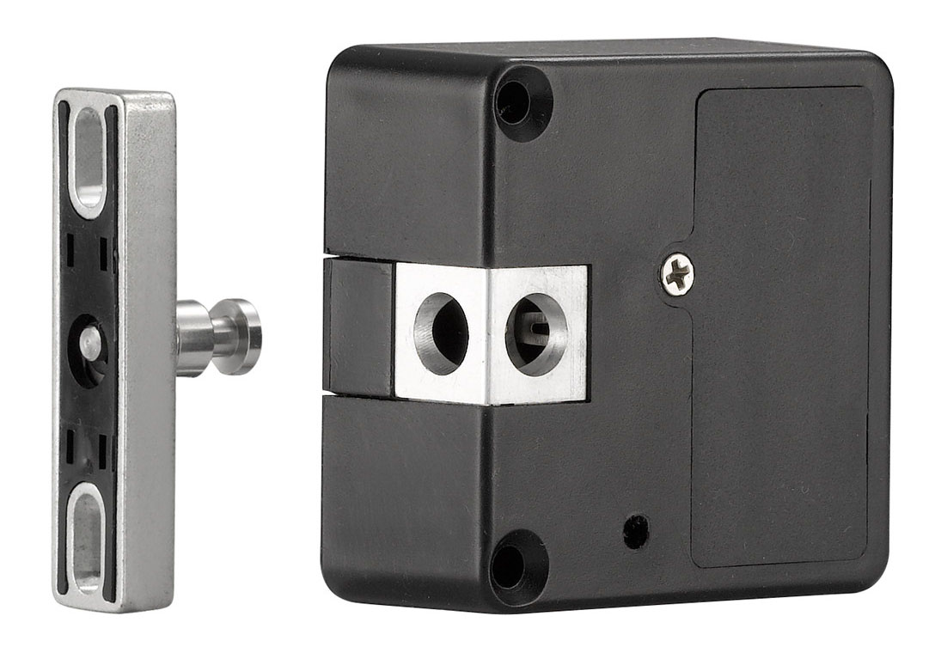

Universal Cabinet Lock User Manual

1----------------------------------------------------------------------------------------Package
2----------------------------------------------------------------------------------------Installation Guide
3----------------------------------------------------------------------------------------Program Main Card Steps
4-----------------------------------------------------------------------------Low Voltage Alarm

1, Package:
 | 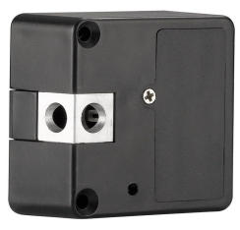 | 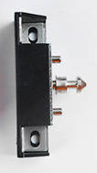
Sticker | Lock Body | Latch
 |  | 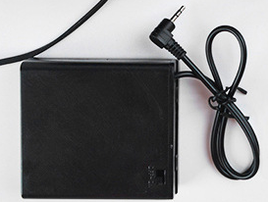
Main Card | Screws | Power Supplier(Additional Purchase)

2, Installation Guide
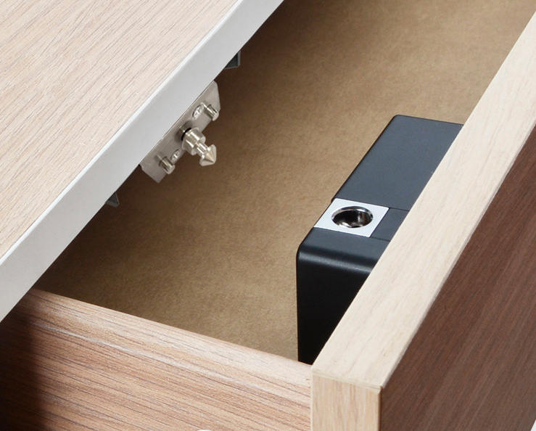

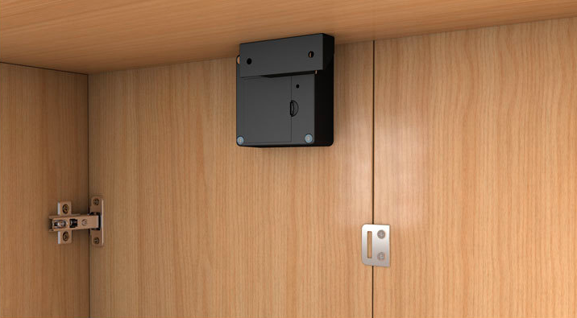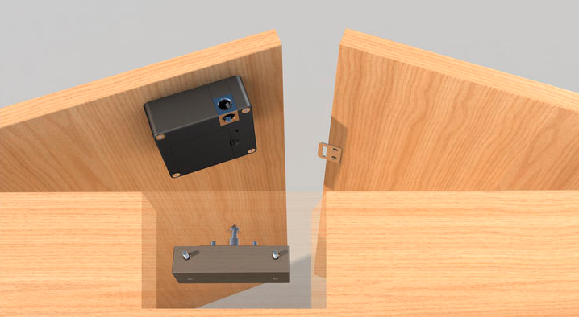
3, Program Main Card Steps
3.1 Initialization button is beside battery box, inside the small hole. Use a toothpick or slight stick to press the button.
3.2 Release toothpick or slight stick after a “beep” sound, lock will be single card mode.
Release toothpick or slight stick after 2 “beep” sounds, lock will be double card mode.
* Single card mode means lock can be opened by main card or key card
* Double card mode means lock just can be opened by reading main card(first) and key card.
3.3 After initialized, the first and second card read on lock will be main card.
* If one main card lost, read another main card 3 times, after a long “ beep” sound, read a new card, this card will be the second main card, at the same time, the lost main card failed.

4, Low Voltage Alarm
4.1 When voltage is low, there is a 8 times “beep” sound after read key card, and then lock bolt will not extend, lock will be normal open mode. Please replace all batteries.
* Read main card 9 times can close low voltage alarm function or active this function. The default mode is activated.

