Access Control Reader
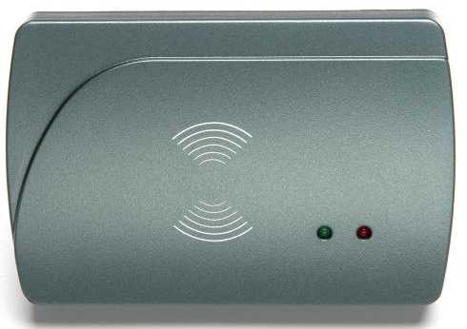
1 Parts
- Access Control Reader

2 Wire Diagram
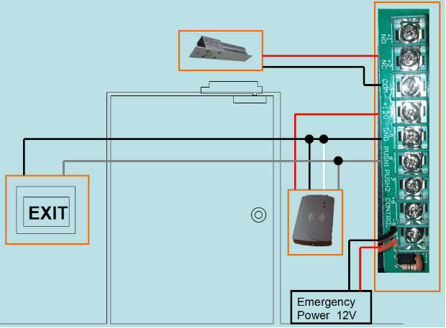

Necessary Accessory
- Electronic Bolt Lock
- Exit Switch
- Power Supplier

3 Settings
1) Read System Card
2) Read Room NO. Setting Card(Add a room in software, floow = 0, room number = 0)
3) Read Time Card

