206 Password Cabinet Lock User Manual

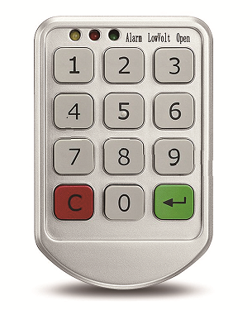

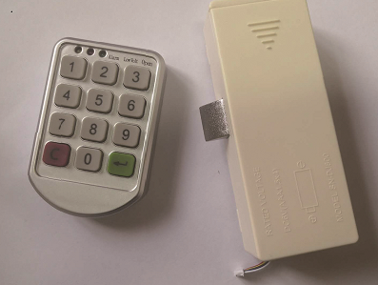
(键盘和锁芯的图片，看下用自己拍的好一点还是直接用这个图，我这边只有这两个图)

1, Product Size

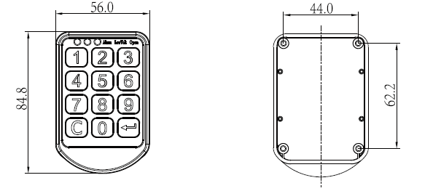
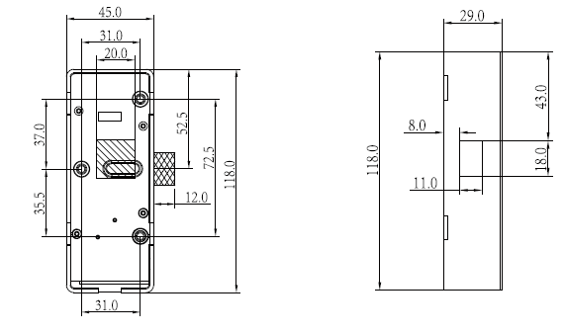
（看下这个尺寸图片要不要改，我是从英文说明书截图下来的）

2, Parts
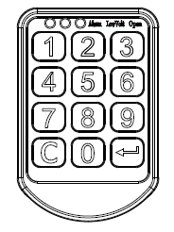 | 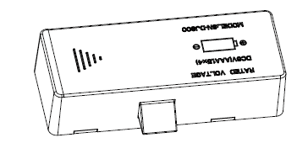 | 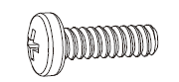 | 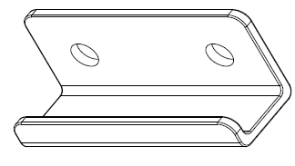
Keypad*1pc | Mortise*1pc | Screws | Strike*1pc
（这几个图都是从英文说明书上截图的，看下要不要改）
3, Installation Steps
3.1 Drill hole on cabinet door.
3.2 Fix Keypad on door front side.
3.3 Fix mortise on door back side.
3.4 Fix Strike based on mortise position.
3.5 Install batteries (4pcs AAA batteries)
3.6 Test the functions

4, Operation Introducing
Note:  for confirm;  for cancel

4.1 Factory default password
The default master password when first operation is “00000000”.
The default user code when first operation is “1111”.

4.2 Operation
a, Input correct password(4~10 digits are available);
b, Password correct, green LED lighting, latch moving in;
Password incorrect, yellow LED flashing, latch not move
c, Open the door

4.3 Mode Setting
There are 2 modes of these password cabinet lock: private mode and public mode.
Private mode:
Password: Password is private and fixed.
Operation: Close the door; Input correct user password to open the door.
Public mode:
Password: Password is set by casual user before every time to close the door. When lock at opening status, push the door to close, and input a password you want, press to confirm, door lock.
After door opened by this password, it invalid, lock will standby and waiting for next user to use.

Private Mode change to Public Mode:
Step 1: Press
Step 2: Press
Step 3: Press “4”
Step 4: Press
Step 5: Input Master Password
Step 6: Press

Public Mode change to Private Mode:
Step 1: Press
Step 2: Press
Step 3: Press “5”
Step 4: Press
Step 5: Input Master Password
Step 6: Press

4.4 Password Setting
a, Change User Password(For Private Mode)
Note: User code can be saved even power fail, and 4~10 digits password available.
Step 1: Press 2 times;
Step 2: Input old password;
Step 3: Press ;
Step 4: Input new password;
Step 5: Press ;
Step 6: New password saved and effective; Green LED lighting, buzzer make 2 “beeps” means password changed successfully.

b, Change Master Password(For Private Mode and Public Mode)
Note: 6~10 digits numbers are available, can be saved even power fail. To make sure safety, it should be changed by admin of locks.
Step 1: Press for 5 seconds; Yellow LED flashing;
Step 2: Input old master password;
Step 3: Press ;
Step 4: Input new master password;
Step 5: Press ; Green LED light, buzzer make 2 “beep” sound means change successfully;

5 Password Protection Function
Input wrong password, yellow LED flash 4 times, and buzzer make “beep” for 4 times;
If input wrong password continuously 3 times, system will lock for 1 minute, and not work by any operation.

6 Low Power Alarm
Wen batteries power is low, input code to open lock, red LED will flash and with 4 groups alarm;
When alarm for low voltage, lock still can be opened for 200 times.

7 Emergency
7.1 If user password forget, please use master password to open lock, user password will become to default “1111” after lock opened.
7.2 When batteries power low, please open lock with a battery box.

