ID Card Lock Manual

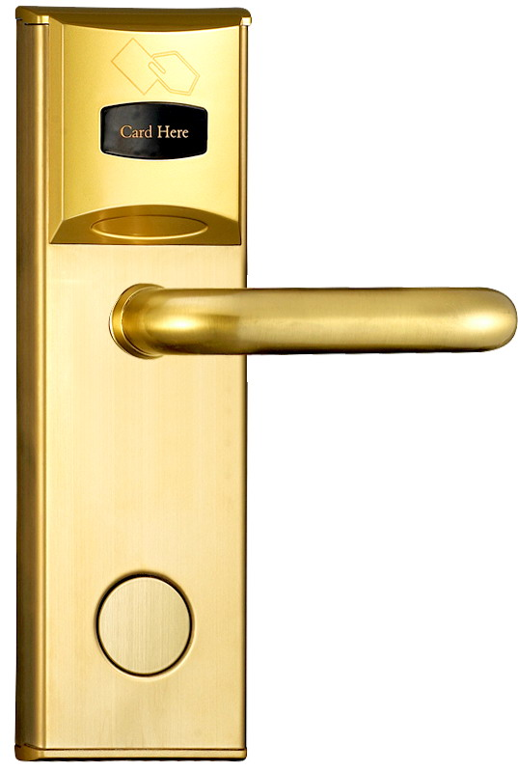

Key card: ID Card
Product Introduction:
▶ID Card
High level of security and stable performance
▶Passage Function
Can set lock to passage mode,no need card and mechanical key to open.
▶Configuration and Delete
It is very easy to configuration and delete card.
▶Remind Function
Lock will remind when door is not open correct

Technical indicators:
Power Supply:6V,4*AA alkaline batteries
Open Times: with 4*AA alkaline batteries >10000
Static Current:<40mA
Dynamic Current:200mA
Low Voltage Detection:4.8V
Identification Speed:0.5~1.5s
Card Configuration:199pcs

Operating Instructions:
1,Lock Initialization
Please initialize locks before install.

Turn mechanical key 5 times, a ‘beep’ sound when each turning, a long ‘beep’ sound after 5 times turning, than all key card are deleted.

2,Main Card Configuration
An empty lock(Data cleared), read the first card as the main card. Configuration success when a long “Dee~” sound.
Main card can be used for : open lock, configure key card, clear data of lock.

3,New Key Card Configuration
Read the main card, lock open, blue light flash, it means lock is ready to configure key card.
Configure Key Card:
When lock is ready to configure, read a blank card, configure successfully when a “Dee~” sound.
*If red LED lights up, means data is full.
*After configuration, press handle or wait for blue LED lights down can finish configure action.
Note: After read main card, lock opens,it will skip configure action when press lock handle.

9,Clear Key Card
Two ways:
- Initialize lock, configure a new main card.
- Read the main card, when a “Dee~”sound,read 5 times the main card, then lock will make a long ‘Dee~” sound, means all key card and remote controller cleared.

10,Set Passage Mode
Press back handle and read any one key card
*Cancel passage mode:read key card to open lock to cancel passage mode.

11,Lock Warning
If lock do not close normally, there will be a warning sound.
When lock in passage mode, no warning.

12,Deadbolt
When lock deadbolt, lock can not be opened by key card.

Reload Batteries
When lock opened, red LED lights up,means voltage under 4.8V, need reload new batteries.
If continue to open lock for 20 times, lock will not be opened, and 6 times “Dee~” sound.

Note:
*Lock batteries are alkaline 1.5V
*Remote controller battery is alkaline 12V,23A
*If handle or panel damaged,please buy and replace new.

